Mihai Glodici, Jorn Kosterman, Soufiane El Atmani

Design Document

Infrastructure Semester 3

Table of Contents

Agreements 2

Requirements 3

Device specific requirements: 3

In AWS: 3

On Premise: 3

System setup/configuration 3

Own configuration 4

Project configuration: 4

Software 4

Hardware 4

Network configuration 4

Network drawings: 5

IP Table: 5

Description 6

Diagrams 6

# Agreements

We have made the following agreements with our tutor:

1. We will have a meeting with our tutor every week to discuss our progress.
2. We will take notes of the meetings.

# Requirements

In this part we will describe what our systems/servers are supposed to do:

## Device specific requirements:

### In AWS:

VPC-1: This virtual private cloud network will consist of two connected subnets; one will be used for hosting our web-APP on an EC2 instance, and the other will be used for our databases; because they are within the same VPC, they can communicate without any additional configuration.

WEB-01: This is an EC2 instance that will run apache2 for our website. This EC2 instance will be connected to the main database, where it will store and retrieve user credentials for new and existing users.

RDS-01: This will be our primary database where we will store a variety of data, including user credentials and possibly logs. This database's entire contents will be replicated to the redundant database instance.

RDS-02: This database instance will replicate everything from the primary database instance in the event that the primary database instance experiences a problem.

A load balancer will be implemented, and when usage exceeds 90 percent for more than 5 minutes, a second instance of our infrastructure will be automatically created.

CloudWatch, CloudTrail, and SNS Service will be used to monitor our instances and network traffic and generate alerts.

Amazon Web Services' Route 53 will serve as our DNS server of choice.

### On Premise:

STRG-01: This server will function as a storage server for large video files. This network will be connected to the AWS environment via a VPN connection, and files from this server will be accessible via the AWS-hosted website.

*The rest of the requirements can be found in the MoSCoW table in the Project plan*

# System setup/configuration

In this chapter we will talk about the system setup/configuration

## Own configuration

The laptops that we are going to use are as following :

* Laptop Soufiane:

Windows 10 laptop with a RYZEN 7 5800H CPU, RTX3060 6GB laptop GPU and 16GB of RAM.

* Laptop Jorn:

Windows 11 laptop with a RYZEN 5 5600H CPU, RTX3060 6GB laptop GPU and 16GB of RAM.

* Laptop Mihai:

Windows 10 laptop with a RYZEN 7 5800H CPU, RTX3070 6GB laptop GPU and 16GB of RAM.

## Project configuration:

### Software

Which device uses which software can be found in the table below:

|  |  |  |  |
| --- | --- | --- | --- |
| Nr. | Name | Role | Operating system |
| 1 | STRG-01 | Stores videos and files on the local on premises server | Windows server datacenter 2022 |
| 2 | RDS-01 | Main database | MySQL |
| 3 | WEB-01 | Virtual machine that hosts our website | Ubuntu 20.4 |
| 4 | AWS S3 bucket | Stores videos and files on AWS | AWS ELS |
| 5 | RDS-02 | Redundant database for our main database | MySQL |

### Hardware

We will use virtual hardware in the AWS cloud and one physical server on-site.

Physical Dell server with Windows 10 server OS, a Xeon e5530, 48GB RAM, and 1TB of storage space.

***We do not deliver this hardware as part of this project\****

# Network configuration

## Network drawings:

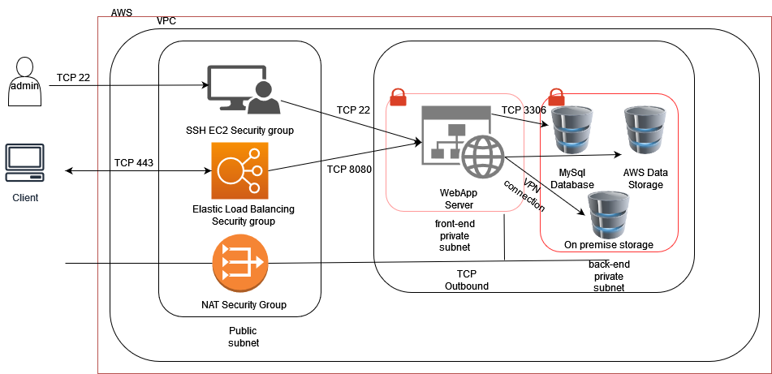

## IP Table:

|  |  |  |  |  |
| --- | --- | --- | --- | --- |
| Nr. | Name | IP | Subnet | DNS |
| 1 | VPC-1 | N/A | 10.0.0.0/16 | N/A |
| 2 | RDS-01 | 10.0.0.3 | /16 |  |
| 3 | WEB-01 | 10.0.0.10 | /16 |  |
| 4 | AWS S3 bucket | N/A | N/A | N/A |
| 5 | RDS-02 | 10.0.0.4 | /16 |  |
| 6 | VPN | 10.0.1.8 | 10.0.1.0/24 | 8.8.8.8 |
| 7 | STRG-01 | ? | ? | ? |

## Description

Since we will be using VPC, we have one or more subnets where we will place nearly all of the above-described machines and services (Except the VPN and storage server).

NOTE: This IP Table is not yet complete, which means we will make modifications as we implement our ideas.

# Diagrams

In this chapter, we will display a variety of diagrams for the applications and services that run on our network.

